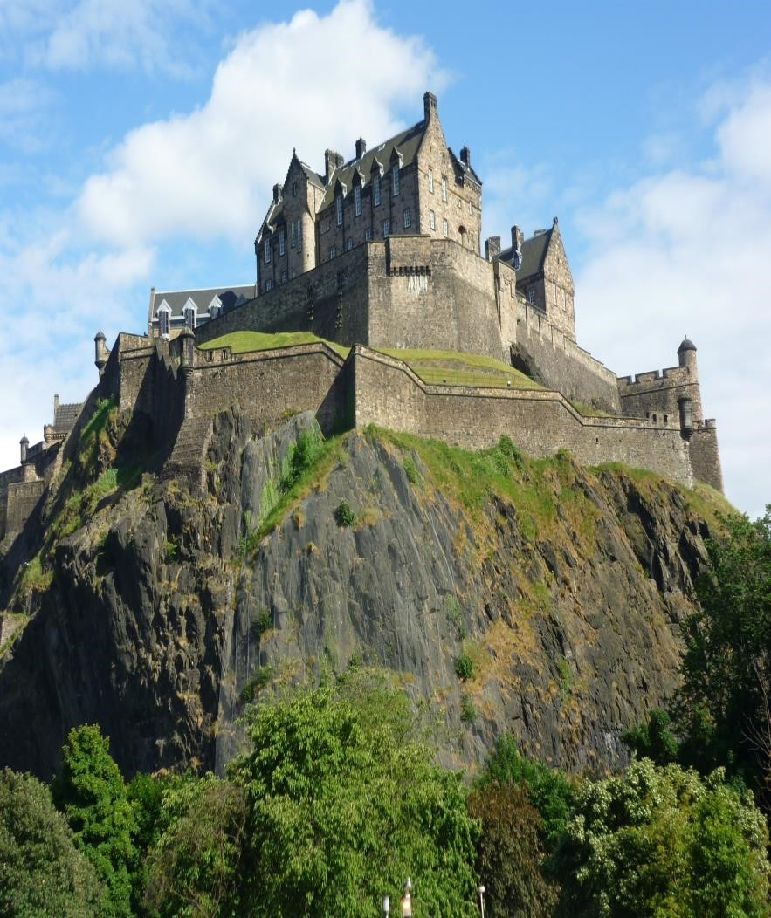
Sample Itinerary

STUDY AWAY

Ireland, Scotland, and England

Course

International Marketing: Repositioning and
Repurposing Castles for the Tourist Market

Student Itinerary- Ireland, Scotland, and England
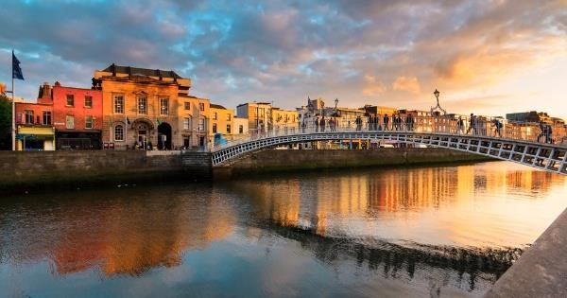

Monday, May 22nd : St. Louis
11:15am: Coach to Airport
2:45pm: Arrive at Airport
LUNCH: On Own at Airport
5:45pm: Flight 7386 to Toronto

DINNER: In Flight or at Airport
11:10pm Toronto to Dublin, IE – Flight 1908
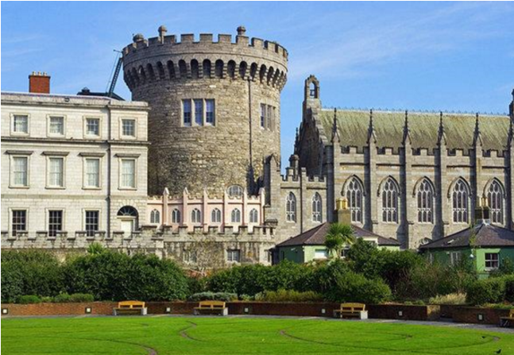

May 23rd: Dublin
BREAKFAST IN FLIGHT
10:45am: Arrive in Dublin
11:00am: Drop Off Luggage at Hotel/check in
12:30pm: LUNCH – Self Pay with Group
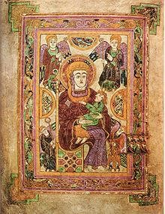
1:30pm: Dublin Castle, Guided tour – Self Pay at Castle
3:00pm: Trinity College / Book of Kells
4:30pm: St. Patricks Cathedral
6:00pm: St. Stephen’s Green
7:00pm: DINNER: Self Pay with Group
HOTEL: Dublin, Ireland

May 24th : Dublin
7:30am: BREAKFAST AT HOTEL
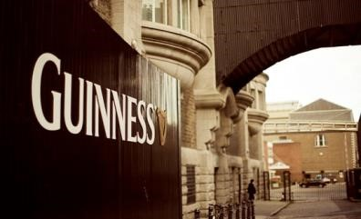
8:45am: Leave Hotel
9:30am: Guiness Storehouse
11:00pm: LUNCH: Self Pay at Brewers Dining Hall in Guiness Storehouse
12:30pm: Kilmainham Gaol – private tour/lecture
3:00pm: National Museum
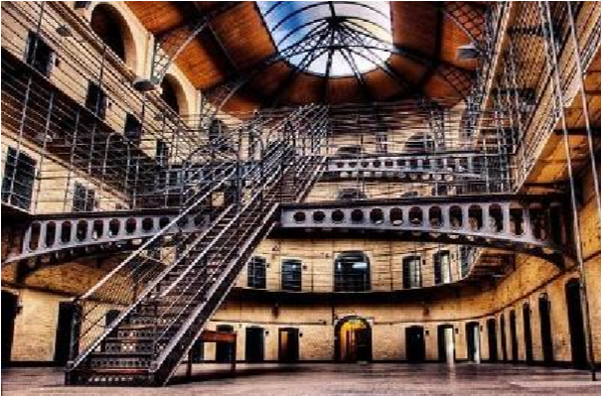
5:00pm: Spire of Dublin and Jervis Shopping Center
7:30pm: DINNER: Arlington Hotel Irish Dinner Show/ Celtic Nights 8:30pm: Celtic Nights Irish Dance Show
HOTEL: Dublin, Ireland

May 25th : Dublin / Blarney
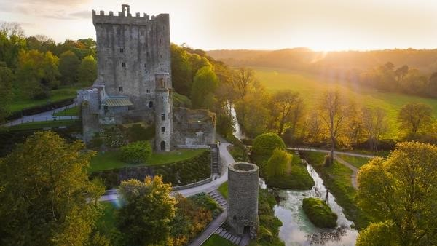
6:00am: BREAKFAST AT HOTEL
7:00am: Guided Tour to Blarney Castle
10:00am: Blarney Castle
12:30pm: LUNCH: Self Pay at Muskerry Arms
Restaurant
2:00pm: Cork

4:30pm: Leave Cork for Hotel
7:30pm: Arrive at Hotel
HOTEL: Dublin, Ireland

May 26th : Dublin / Cliffs of Moher
6:00am: BREAKFAST AT HOTEL
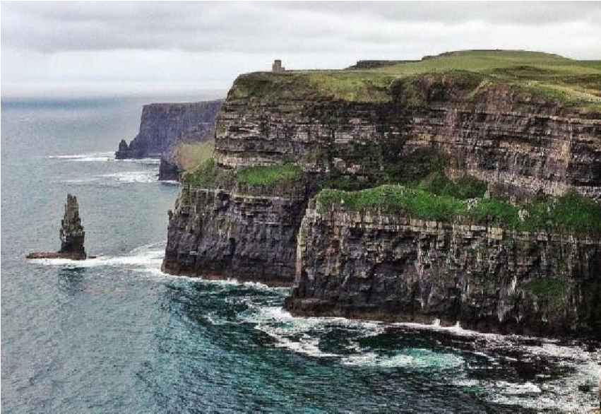
7:00am: Leave Hotel
9:30: Visit Galway (Snack Stop)
11:00am: Leave Galway
1:00pm: Arrive at the Cliffs of Moher
3:15pm: LUNCH at Gus O’Connor’s Pub – Self Pay
7:00pm: Arrive in Dublin
7:30pm: DINNER: On Own Self Pay
HOTEL: Dublin, Ireland

May 27th: Edinburgh / Glasgow / Aryshire
4:00am: Leave for airport
6:25am: Flight from Dublin to Edinburgh – Ryan Air FR812
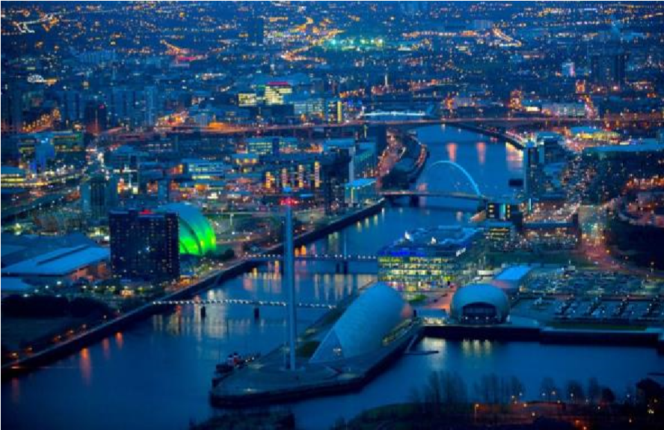
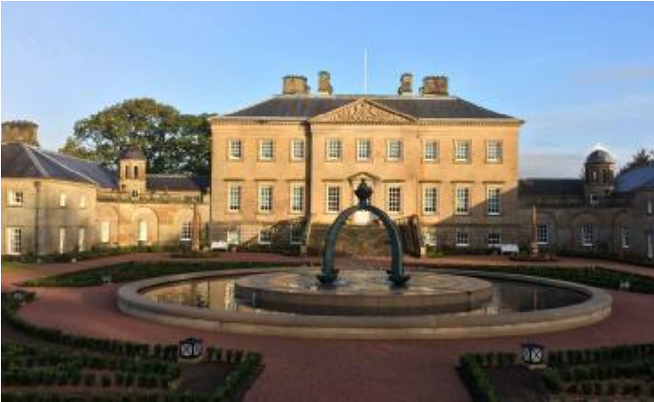
7:35am: Arrive in Edinburgh
8:00am: Bus to Dumfries House
9:30am: Dumfries House – private tour/arranged lecture – Administration and Marketing of Dumfries House
BREAKFAST AT DUMFRIES HOUSE
11:00pm: Bus to Glasgow
12:00pm: LUNCH: Self Pay in Glasgow
1:00pm: Tour of Glasgow
5:00pm: Return to Edinburgh
8:00pm: Return to Hotel
HOTEL: Edinburgh, Scotland

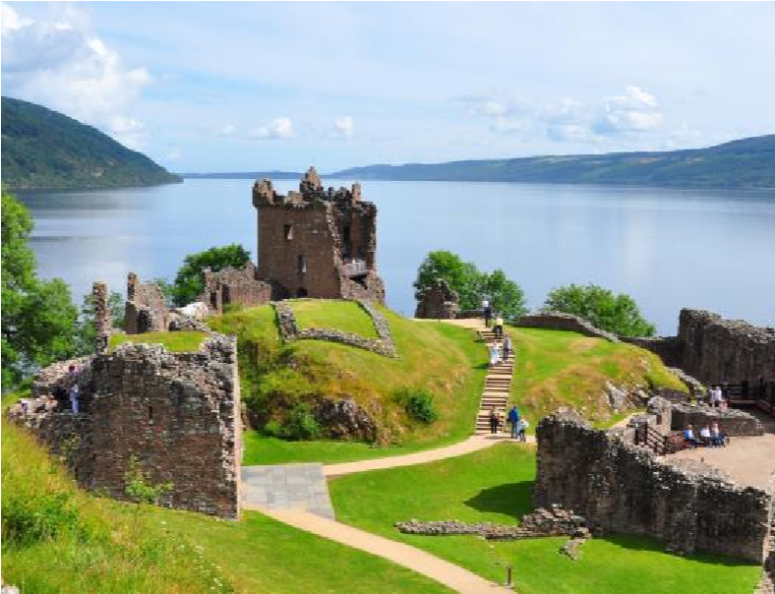
May 28th : Edinburgh / Loch Ness
7:00am: BREAKFAST AT HOTEL
8:00am: Loch Ness Cruise & Tour of Urquhart Castle
HOTEL: Edinburgh, Scotland

May 29th : Edinburgh
7:00am: BREAKFAST AT HOTEL
EVERYONE NEEDS 4 POUNDS IN EXACT CHANGE FOR DAY BUS TICKET
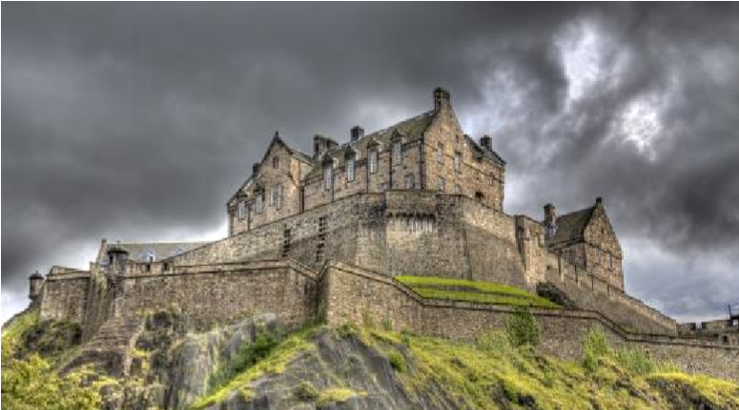
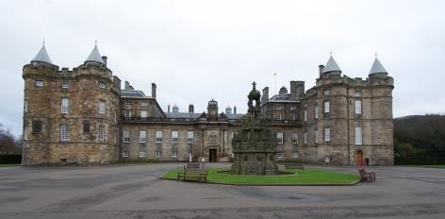
8:00am: Edinburgh Old Town/Royal Mile

9:00am: Holyrood Palace – audio tour
11:30am: LUNCH: Self Pay- Deacon’s House Cafe
12:30pm: Edinburgh Castle
3:30pm: Return to hotel & Airport
6:15pm: Flight to London – Ryan Air FR8888
7:40pm: Arrive in London
8:30pm: Dinner On Own
HOTEL: London, England

May 30th : English Countryside
7:00am: BREAKFAST AT HOTEL
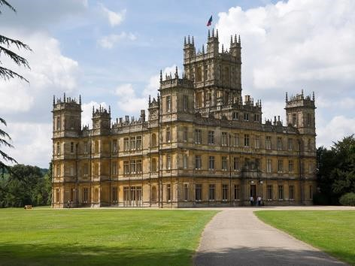
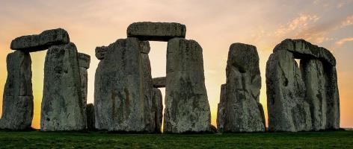
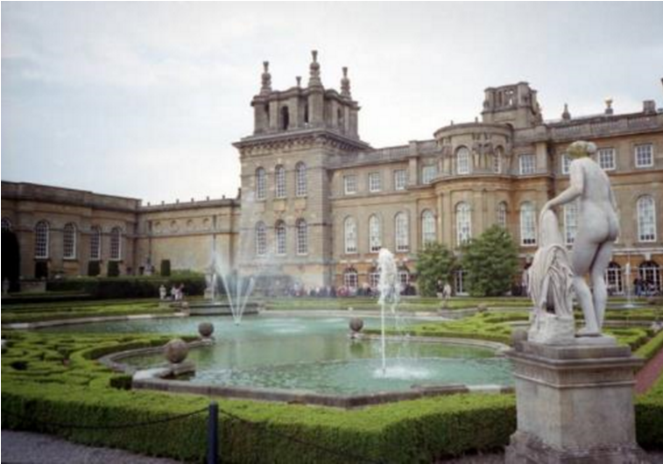
7:30am: Leave Hotel

9:30am: Stonehenge
11:30pm: Lunch to go The Green Tree Café and Deli
12:00pm: Leave for Blenheim Palace with Photo Op @ Highclere
2:00pm: Blenheim Palace – guided tours
5:30pm: Return to London
7:00pm: DINNER: Self Pay - On Own in
London
HOTEL: London, England

May 31st : London
8:00am: BREAKFAST AT HOTEL
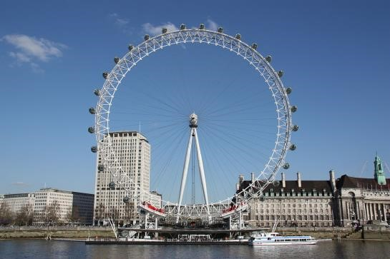
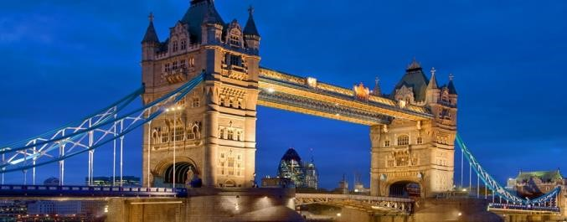
9:00am: Leave hotel for the Eye

10:00am: The Eye
11:00am: River Cruise
12:00pm: LUNCH: Self Pay- Subway/
KFC/ Starbucks/ Ben & Jerrys/ Fish Bar or Pret
1:00pm: Tower Bridge tour
2:00pm: Tower of London / London Wall
5:000pm: FREE TIME
6:00pm: DINNER: On Own
HOTEL: London, England

June 1st: London
8:00am: BREAKFAST: At hotel
8:30am: Leave for St. Pauls Cathedral via Millinnium Bridge
9:00am: St. Paul’s Cathedral - tour
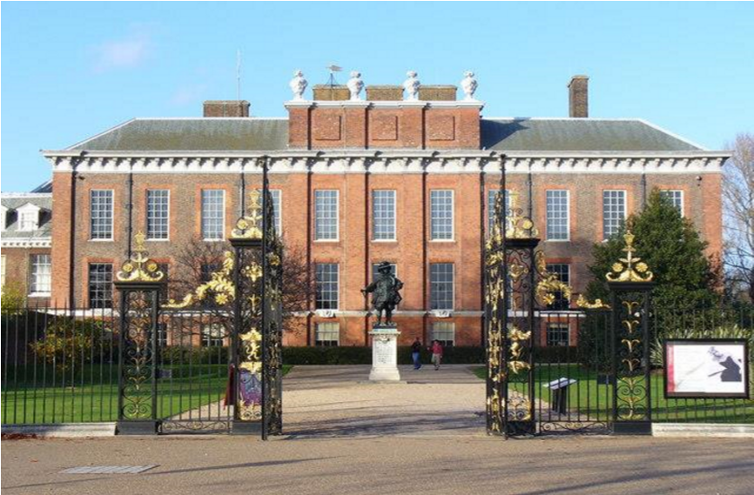
11:00am: Leave for Kensington Gardens
12:00pm: Arrive Kensington Gardens/ Walk to Lunch
12:30pm: LUNCH: Self Pay at Speghetti House Kensington High Street
1:30pm: Kensington Palace tour
4:00pm: Harrod’s
6:00pm: DINNER: Self Pay at Harrod’s or On Own
HOTEL: London, England

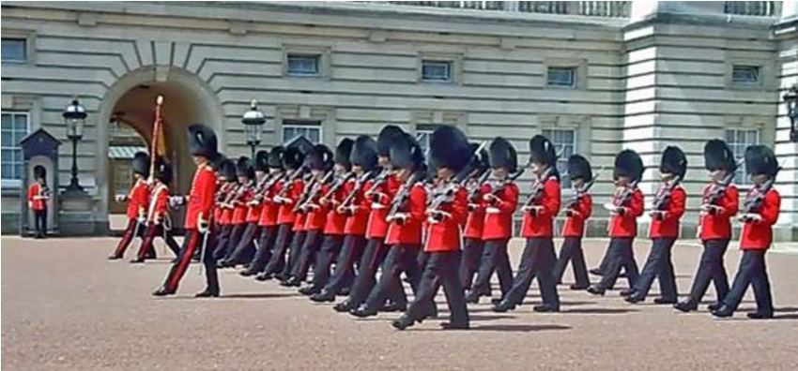
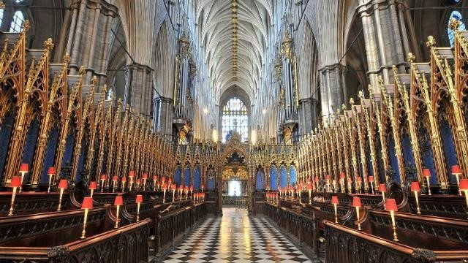
June 2nd : London
7:00am: Breakfast
8:00am: Talfagar Square
9:00am: Walk to Buckingham Palace
11:00am: Buckingham Palace: Changing the Guard and the Mews
1:30pm: Westminster Abbey – audio tour
3:20pm: Palace of Westminster – audio tour
7:15pm: DINNER: Medieval Banquet
HOTEL: London, England

June 3rd : Dublin
4:00am: Leave for Airport
6:30am: Flight from London to Dublin – Ryan Air Flight FR203
BREAKFAST ON FLIGHT OR AT AIRPORT: Self Pay
12:25pm: Flight from Dublin – Air Canada 1909
LUNCH IN FLIGHT OR IN AIRPORT: Self Pay
2:45pm: Arrive in Toronto, CA
4:10pm: Flight from Toronto to St. Louis – Air Canada 7387
5:15pm: Arrive at Airport
9:00pm: Coach from Airport

