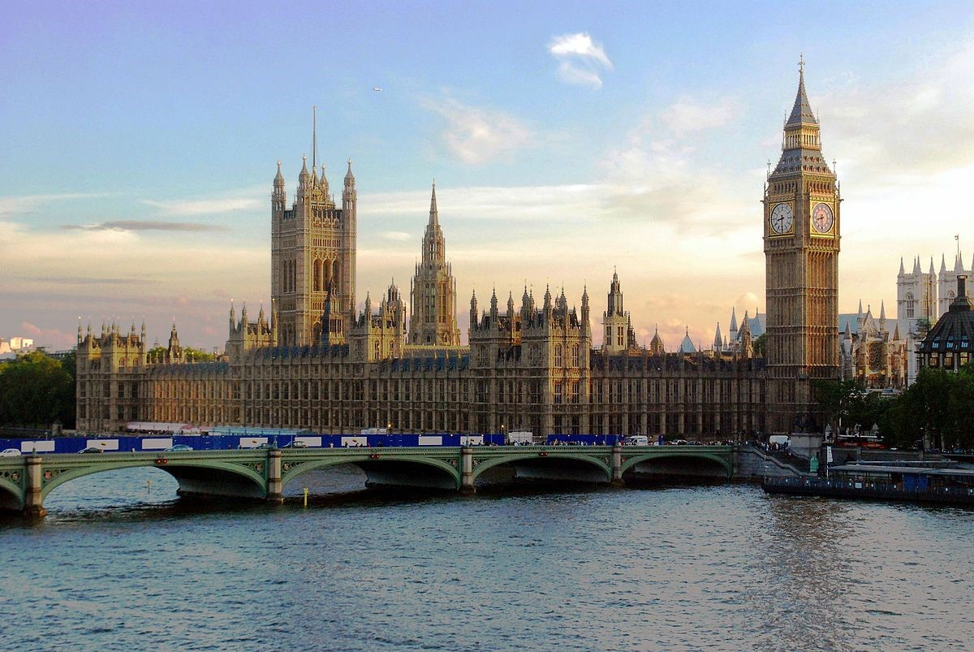
STUDY
ABROAD
UNIVERSITY OF NORTH GEORGIA

LONDON

SUMMER 2020
May 5 to May 13, 2020​

PREPARED FOR xxxx yyyy
PREPARED BY xxxx yyyy
Custom Programs Proposal
University of North Georgia in London
Faculty-Led Short-term Study Abroad Program
CRIMINAL JUSTICE MAJORS – LONDON, ENGLAND
Summer 2020

Xxxx yyyy, Professor  82 College Circle  University of zzzzz, xxx, yyyy 30597  xxxyyy@ung.edu | Xxxx yyyy, Travel Consultant uAdventure, LLC Travel  The Hammons Tower  901 E. St. Louis St. Suite. 200-9  Springfield, MO 65806  (417) 766-4052  kayla@uadventuretravel.com

uAdventure, LLC Travel

901 E. St. Louis St., Suite 200-14
Springfield, MO 65806
(417) 771-8885
adventuremaker@uadventuretravel.com www.uAdventureTravel.com
FB: @uadventuretravel
Instagram: @uadventuretravel Twitter: @uadventure2u

Custom Programs Proposal: March 23, 2019

Custom Group Proposal and Tour Agreement

Client: University of North Georgia
Provider: uAdventure, LLC

uAdventure, LLC Custom Programs are designed specifically for your course. We are dedicated to providing the best possible customer service for faculty-led study abroad, group excursions, corporate groups, and other customized travel packages. We plan the best adventure travel, study, educational and custom tours, tailored specifically to your criteria.
Our Travel Consultant, will serve as the primary contact for your custom group tour throughout all phases of the program, especially during the package design, pre- departure and travel support phases. While abroad, our consultant will work closely with the overseas tour providers, hotels and event provider to troubleshoot any potential problems and manage the day-to-day program operation. We will be available 24/7 to support you during your program.
The client tour group will have a single point of contact (the Program Leader) for group tour planning and communication with uAdventure, LLC throughout all phases of the program.

Minimum Enrollment
10 student participants
1 Faculty Program Leader

Proposed Program Itinerary
The following itinerary is for planning purposes and is tentative. As of the date of this proposal, no part of this itinerary has been booked or reserved and is subject to changes in pricing and availability at the time of booking. The final itinerary will be confirmed with the Program Leader approximately six to eight weeks prior to the departure date. In the event that certain itinerary items are unavailable and compromise the agreed upon program itinerary, the uAdventure, LLC staff will work closely with the Program Leader to make appropriate revisions.

Tentative Itinerary- London

Tuesday, May 5: Atlanta to London 9:25 am: ATL-BOS
5:50 pm: BOS-DUB (overnight)

Wednesday, May 6 6:30 am: DUB-LCY
8:15 am: Arrive in London
9:30 am: Transfer to Hotel Meridian & check in
2:00 pm: Hop-On-Hop-Off City Tour: At your own pace, see the London Eye,
Westminster Abbey, Buckingham
Palace, Trafalgar Square, and more! You choose!
6:00 pm: Dinner at Magpie & Stump, an English pub that’s been around for 500 years! This was a renowned “mughouse” in the 1700’s, where guests would visit, drink ale, and have a view of the hangings outside Newgate Prison. The pub would even send out a last pint to the condemned man before his execution! 8:00 pm: Return to hotel

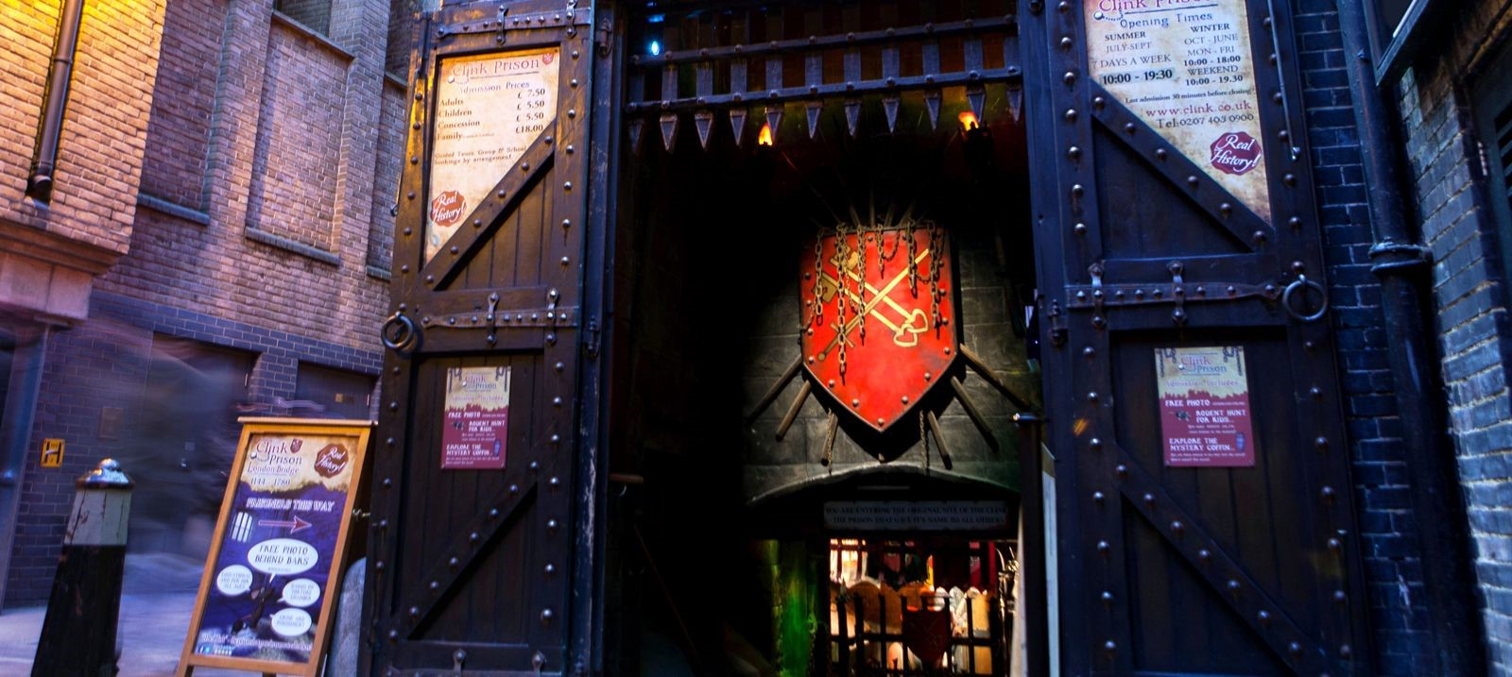
Thursday, May 7
9:00am: Breakfast at Hotel
10:00 am: Transfer to New Scotland Yard; walk around perimeter and take it in!
11:00 am: Transport to the Clink
Prison for Guided Tour 12:30 pm: Free afternoon, lunch on your own
6:00 pm: Dinner at the Clarence

Friday, May 8
8:00 am: Breakfast at Hotel
9:00 am: Tour the City of London
Magistrates Courts & Southwark Crown Courts (within walking distance of each other). Sit in and observe cases while taking in the historical buildings.
12:00 pm: Lunch on your own in
the area
Free afternoon and evening in London (dinner on your own)

Saturday, May 9
9:00 am: Breakfast at Hotel
Free day to visit any of the sites of London you wish!
Lunch and dinner on your own.
6:25 pm: Tube transfer to tour meeting place
6:50 pm: Jack the Ripper Tour (begins at 7pm)— take a walking tour, following in the footsteps of Jack the Ripper and his unfortunate victims in London’s East End. Visit the sites of his murders and learn more about the mysteries and rumors surrounding the unsolved serial crimes.

Sunday, May 10
9:00 am: Breakfast at Hotel
10:00 am: Transit to Tower of London 10:30 am: Visit the Tower of London. See the world-famous crown jewels at one of the world’s most famous fortresses. The tower has been used as a palace, prison, armoury, and even a zoo! Enjoy the views of the River
Thames.
12:00 pm: Lunch at Sargeant’s Mess. This classic British dining experience includes a view of Tower Bridge and the River Thames. 1:30 pm: Visit the London Bridge and explore the underground tombs and learn more
about the haunting tales of the city’s notorious past.
Free afternoon and evening in London (dinner on your own)

Monday, May 11
8:00 am: Breakfast at Hotel
9:00 am: Transfer to Inns of Court and Royal Courts of Justice Tour location. Walk through all four inns of court: Gray’s Inn, Lincoln’s Inn, Inner Temple, and Middle Temple. Walk to the Royal Courts of Justice, and take in the impressive sight!
11:00 am: Transfer to the House of
Parliament for audio tour. Travel through the Commons Chamber and the Lords
Chamber.
12:00 pm: Free afternoon (lunch on your own)
6:00 pm: Dinner at Duck and Waffle. Enjoy a unique English and European dinner with breathtaking views of the city from the 40th floor of the 110 Bishopgate, one of London’s tallest buildings. Duck & Waffle serves breakfast, lunch, dinner, and dessert 24/7!
Return to hotel

Tuesday, May 12
9:00 am: Breakfast at Hotel
Free day and afternoon to explore the city!
(Lunch and dinner on your own) 5:30 pm: Meet at station to transfer to dinner
6:00 pm: Medieval Banquet—experience the Middle Ages through food, drink, music and entertainment! Dance to the disco after dinner if you’re not too full! This 3-hour dinner banquet will be unforgettable. Optional: rent costumes to join in the fun!

Wednesday, May 13
9:00 am: Breakfast at hotel
10:30 am: Coach transfer to airport
1:30 pm: LCY-DUB
4:20 pm: DUB-BOS
9:59 pm: BOS-ATL
12:46 am: Arrive in Atlanta

Program Cost
Cost Per Participant (per person) The program for ​University of North Georgia​ in London will be ​$2,338​* per participant depending on the number of student and faculty participants. See below. *Cost per participant is subject to Air Rate (described below) and based on triple occupancy. Single occupancy rooms may be subject to an additional charge.

Faculty Program Leader Costs​ (per person): The Faculty Program Leaders will have single occupancy rooms unless otherwise specified.

If faculty program fee is to be paid by students (per person)
The Program fees are calculated below per student participant to include the prorated cost of faculty member’s program fee to be paid by the students.

TABLE BELOW FOR QUOTE INCLUDING AIRFARE ESTIMATE

Paying participants | Cost per person | Cost per person with students paying for  1 faculty | Cost per student with students paying for 2 faculty
*at least 10 | $2299.49 | $2421.49 | $2543.49
*11 to 17 | $2249.49 | $2371.49 | $2493.49
*18+ | $2199.49 | $2321.49 | $2443.49

TABLE BELOW FOR QUOTE ​NOT​ INCLUDING AIRFARE ESTIMATE

Paying participants | Cost per person | Cost per person with students paying for  1 faculty | Cost per student with students paying for 2 faculty
*at least 10 | $1354.99 | $1423.99 | $1492.99
*11 to 17 | $1304.99 | $1373.99 | $1442.99
*18+ | $1254.99 | $1323.99 | $1392.99

Included
Program cost includes items listed in the itinerary, with exceptions.

Ground Transportation
Transportation and airport transfers are included as noted. If not shown, transport by public transportation (i.e. Bus/Metro passes) or walking.

Hotels
Hotels are centrally located in each city. Participants will be housed in shared rooms. Occupancy may be double, triple or quadruple occupancy. Hotels will be as shown on the itinerary or similar. A similar hotel will be a hotel of a similar rating (typically 2 or 3 star). All occupants sharing a room will be of the same gender.

Meals
Hotel bookings include a continental or buffet style breakfast (shown) ​7 breakfasts are included in this proposal. ​3 Dinners​ and 1​ Lunch​ is included in this proposal, other lunches and dinners are included in this proposal.

Activities and Events
Activities and events will be scheduled as availability provides. The days or times shown on the itinerary may be adjusted during booking as final details are confirmed.

Airfare
Airfare is included in this quote. However, while we will book flights on your behalf, rates and availability cannot be guaranteed. The airfare is quoted at the lowest economy rate available to us as of ​3/23/2019​. The Air Rate in this proposal is based on those flights. (Note: See Contract Payment Procedures below for booking requirements).

Air Rate
Total quoted Air Rate included in this proposal for airfare is: ​$945​ per person. We will do everything possible to secure the lowest rate available at the time of booking (Group rates can vary widely depending on demand). In the event uAdventure, LLC is unable to secure flights for the quoted Air Rate, then available rates will be provided to the client for approval. If available rates are above the quoted Air Rate, uAdventure, LLC Travel will present the airline contracted group invoice or other payment invoice for airfare to the client, and the client will be reimburse uAdventure, LLC any cost above the quoted Air Rate. The client may opt to purchase air separately, or make participants responsible for their own airfare. In that case, the program fee may be reduced by the quoted air rate.

Not Included
This proposal does not include required student fees by the client. Specifically excluded are administrative student fees, vaccinations, medical consultations, safety and security training fees, health insurance fees, travel insurance, medical insurance, and other client imposed student fees. Each individual traveler is responsible for securing his or her own travel documents including passports, visas, and medical disclosures. uAdventure, LLC does not provide passport or visa services. uAdventure, LLC understands that your students are travelling on a budget. We make every possible effort to maximize the benefits to your students at the most cost-effective rates. We are willing to work with you to achieve a competitive price to meet the needs of your students. If you receive a lower price on any part of this proposal, or would like to discuss changes to price or activities, please contact your Travel Consultant.

Trip Insurance
(Interruption/Cancellation) Trip insurance is optional. This proposal does not include trip insurance. uAdventure, LLC offers trip insurance through AIG Travel Guard ©. Unless otherwise specified, we will provide quotes under AIG’s Silver Plan. Students and Faculty are eligible to purchase this insurance individually from us during registration. The Certificate of Insurance can be downloaded here. Students and faculty participants can purchase trip insurance from uAdventure, LLC in the forms on our website if desired.

Next Steps

Acceptance of Itinerary
If the proposed itinerary is generally acceptable and you decide to partner with uAdventure, LLC, please let us know by e-mail and we will move forward with preparing a contract for services, marketing, registration, booking and payment arrangements.

If itinerary modifications are required, the client Program Leader will work closely with our Travel Consultant to discuss modifications, participant costs and additional requirements to finalize the itinerary. Upon completion of an acceptable itinerary, the Program Leader will notify uAdventure, LLC to proceed with the following:

Marketing
Upon acceptance of the proposal and itinerary uAdventure, LLC will help with marketing your program. We are dedicated to helping make your program a success. While coordinating the logistics of travel for your program is essential for a great student experience, recruiting students for your program is essential as well. We would like to help you to market your program to students on your on campus. We have years of experience recruiting students for study abroad programs and we have an expert marketer on staff. We will help create marketing materials, including, a PDF poster, a PowerPoint Presentation, e-mail template for direct mail distribution, and student handouts. We will also discuss a marketing plan and distribution schedule for marketing materials to students.

Program Registration uAdventure, LLC will require specific information from each traveler for booking purposes. We have a system of secure online forms which will be made available to participants for registration. Participants will first be required to submit several documents in order to complete booking. The following forms are required for all participants in all Custom Programs:
- General Information Form
- Code of Conduct and Hold Harmless Agreement Form
- Medical History Self-Disclosure and Waiver Form
- Passport Copy (scanned and uploaded)
- Travel Responsibility, Visa, Medical and Travel Document and Release Form

All forms will be due by the Final Forms and Payment deadline. If participants do not complete all forms and applicable payments to uAdventure by this deadline, uAdventure will begin communications with the client and the participants about any applicable penalties, including withdrawal from the program.

Participant International Insurance
The client agrees to provide verification of medical and liability insurance for participants to the provider. uAdventure, LLC requires that each participant and faculty leader be covered by an international medical insurance policy. uAdventure, LLC does not provide medical insurance for individual travelers. Participants should consult with their current insurance provider to confirm coverage policies while traveling abroad.

Provider Liability uAdventure, LLC is insured with Hiscox, Inc., 520 Madison Ave., Floor 32, New York, NY 10022. We hold General/Aggregate liability of $1,000,000/$2,000,000. We will provide our clients with a certificate of insurance. Client can be named additional insured upon request.

Contract for Services
This proposal is not a contract. Upon acceptance of the proposal and itinerary by the
Program Leader, uAdventure, LLC will prepare a contract for services with the client University of North Georgia​. The Contract for services will include the final itinerary and list of services to be provided by uAdventure, LLC, the Provider, along with participant costs, deadline and provisions for cancellation without penalty prior to booking. This contract will be signed by an authorized representative of ​University of North Georgia and an authorized representative of uAdventure, LLC. The contract​ will include a per participant price. The total price will be calculated and invoiced later based on the successful recruiting of participants and the final number of participants.

Booking
We cannot book or reserve any flights, accommodations, activities, events or tickets without payment. We must also have all traveler documentation prior to booking flights. Upon acceptance of the itinerary, we will place accommodations on hold as availability and hotel policy allow. Most activities, tickets and events typically require advance payment and will be purchased after payment is received subject to availability. The Travel Consultant will keep you informed of anything we are able to hold without advance payment. At a minimum, a deposit will be required to hold flights and activities. If the client desires to hold a block of seats on flights with a deposit, the client recognizes that these deposits are non-refundable regardless of the final number of travelers. In most cases, airfare must be paid in full in advance to hold the booking. All airfare must be paid in full if less than 120 days remain until departure. If you would like to provide an advance deposit to hold flights, accommodations or activities, we can arrange that at any time.

Payment
uAdventure, LLC will invoice the client for the total of services based upon the final number of participants. Payment is due in full 120 days before departure, however, earlier payment will frequently allow for better flight arrangements. uAdventure, LLC is an independent affiliate of Nexion, LLC, a branch of Travel Leaders Group, and our host agency. Two invoices will be submitted for payment, One will be payable to Nexion, LLC via a single wire transfer, the other will be made payable to uAdventure,
LLC Travel by single wire transfer. Wire transfer advice will be provided in the invoice
(Payment by credit card will require a fee of 3.75% in addition to the program fee). Other acceptable forms of payment can be arranged upon request, but may be subject to additional fees. If you require us to collect payment directly from participants, ask your Travel Consultant to include a participant payment rider with the final contract.

Program Deadlines and Withdrawal Policy

Important Program Deadlines
- 14 days after proposal is submitted (or by April 6, 2019)
▪ Send requested program modifications or proposal approval/rejection by this date. If program is approved, a contract will follow. o 180 days prior to Program Departure (or by November 7, 2019)
▪ Official Decision Deadline. Signed Contract for Services completed.
- 120 Days Prior to Program Departure (or by January 6 2020)
▪ Roster of all program participants sent to uAdventure, LLC with names of participants as shown on their travel documentation, document dates, cell phone numbers and addresses. Upon submission, uAdventure, LLC will begin making final arrangements. Any changes to the program are subject to uAdventure, LLC approval.
▪ Full program payment due to Nexion, LLC and uAdventure, LLC Travel from Evangel University
- 60 Days Prior to Program Departure (or by March 6, 2020)
▪ All forms and payments are due to Nexion, LLC and uAdventure, LLC.
Withdrawal Policy o 120 Days Prior to Program Departure (or by January 6, 2020)
▪ Refunds for withdrawals of any participant after this date will be subject to a non-refundable fee to cover paid airfare plus any incurred costs. o 60 Days Prior to Program Departure (or by March 6, 2020)
▪ Withdrawal of any participant after close of business on this date will not receive a refund.
Final Packet Approximately two weeks prior to program departure, participants will receive their final travel packet.

24/7 Support
uAdventure, LLC is available to you 24/7 while you are traveling. If you have any concerns or unforeseen concerns while on your trip, just let us know. Call us at 1-417-771-8885 anytime.

xxx yyy, Travel Consultant uAdventure, LLC Travel ​
417-771-8885
*all prices subject to change and availability

uAdventure, LLC Travel | www.uadventuretravel.com uAdventure Travel is the premiere travel agency for
University Study Away, Group Travel, Corporate Travel,
Destination Weddings, Honeymoons & Vacation Planning.

