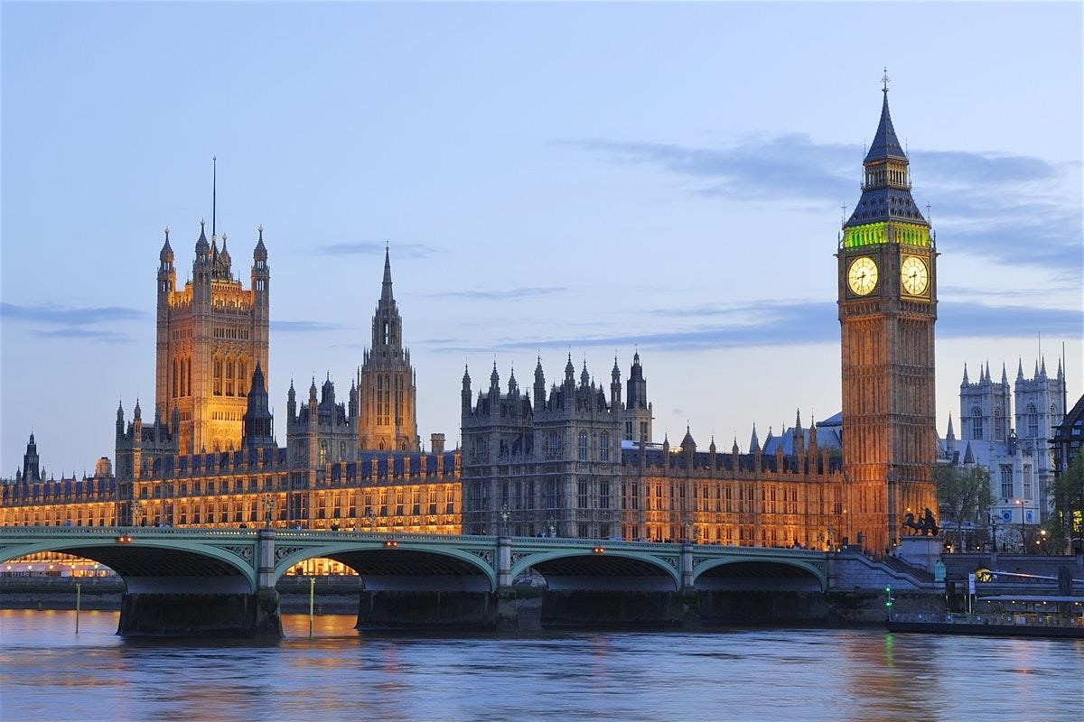

LONDON

Prepared for
XYZ

November 17
th
-

November 28
th
, 2020

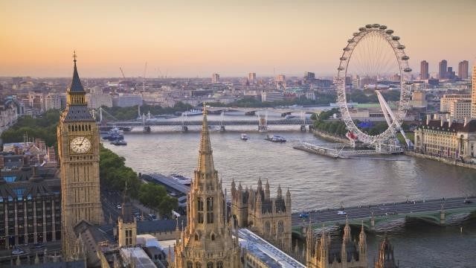
Tentative Itinerary- London
Tuesday, November 17th : Raleigh to London
12:20pm: Flight from RDU to LHR

Wednesday, November 18th: London 7:05am: Arrive in London
7:30 am: Transfer to Park Plaza London Riverbank
9:00 am: Breakfast

HOTEL: Park Plaza London Riverbank
CI Albert Embankment 18-SEI 7TJ
Vauxhall, London

Thursday, November 19th: London
9:00 am: Breakfast at Hotel
10:30 am: Kew Gardens
12:30: Lunch at The Stable (included). Tasty offerings of cider and sour dough based pizza with homemade tomato sauce and local toppings.
2:00pm: The Shard. View the city from its highest and best view from the Shard, with a view of over 40 miles!
4:00pm: HMS Belfast
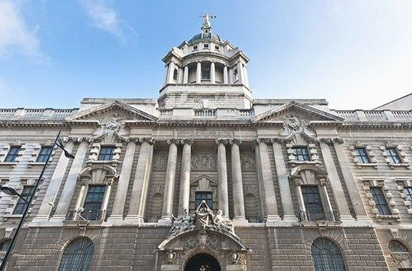
9:30am: Westminster Abbey, where the Duke and Duchess (Kate and William) were married. This church and UNESCO World Heritage Site has been the coronation church of the British monarchy since the 11th century. Charles Dickens and Charles Darwin, among others, were buried on the church’s grounds.

Friday, November 20
th
:
London

8:0
0
am: Breakfast at Hotel

12:00pm: Lunch at The Regency Cage (Included). Old School London. Shephards Pie, Burgers, Corned Beef, Pasties, Fish and Chips.
1:30 pm: Tour of Parliament—discover where history is still being made in the Houses of Parliament! Optional afternoon tea to follow.

Saturday, November 21st: London
9:00 am: Breakfast at Hotel
10:30 am: Visit Little Venice
12:00 pm: Lunch
1:30 pm: Canal Cruise. The original Regent's Canal tour has been operating since 1951. Jason is an authentic 108year-old canal boat which was originally used as a cargovessel on the canals before being fitted with a diesel engine and converted to passenger-carrying duties

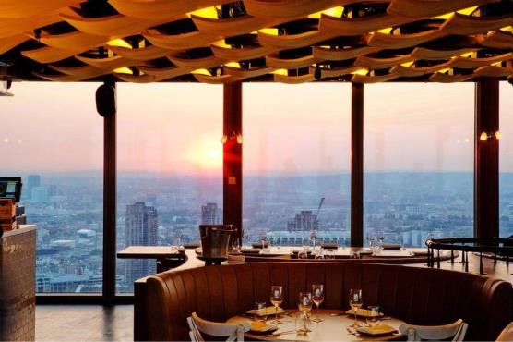
10:30 pm: Kensington Palace. Visit the royal residence set in the picturesque
Sunday, November 2
nd
:
London

9:00
am: Breakfast at Hotel

Kensington
Gardens.

12:00 pm: Lunch at The Spaghetti House (included). A perfect mix of a traditional and modern, intimate and atmospheric italian restaurant right next to Hyde Park.
1:30 pm: Royal Albert Hall. Amazing concert hall and one of the UKs most distinctive buildings opened by Queen Victoria in 1871.
2:30pm: Stroll Hyde Park. Enjoy beautiful surroundings, visit the Diana and Albert memorials and take a ride on a paddle boat.
4:00pm: Harrods. Spend some time shopping for souveniers in this world-famous department store.

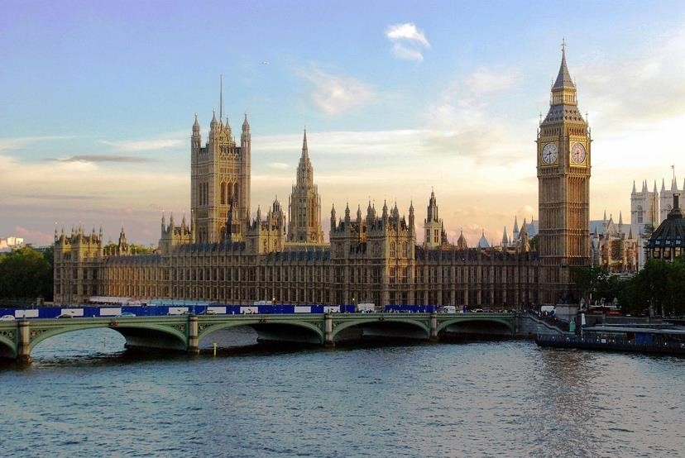
10:00 am: Thames River Cruise. Get a unique view of London aboard a Thames river cruise from the London Eye to the Tower Bridge.
Monday, November 23
rd
:
London

9
:00

am: Breakfast at Hotel

1:30
pm:
Tour

London Bridge and explore the underground tombs and learn more

about the haunting tales of the city’s notorious pa
st.

10:30 am: Tower of London. See the world-famous crown jewels at one of the world’s most famous fortresses. The tower has been used as a palace, prison, armoury, and even a zoo! Enjoy the views of the River Thames.
12:00 pm: Lunch
4:00 pm: Shopping
6:00 pm: Dinner at The Oyster Shed (Included). Riverside seafood and classic British dishes.

Tuesday, November 24th: London
9:00 am: Breakfast at Hotel
10:30 am: Windsor Castle Day Visit (From Paddington). Visit the impressive and historic
Windsor Castle. Famous for its architecture and longstanding Royal place of residence, the Castle was built in the 11th century after the Norman invasion. As well as having been used as a military headquarters during the Civil War and as a refuge for the royal family during WWII, Windsor Castle is now Queen Elizabeth II’s favourite weekend home.

Wednesday, November 25th: London
9:00 am: Breakfast at Hotel
11:00 am: Changing of the Guard at Buckingham Palace. Watch this centuries old ritual . Get there early to get a good viewing spot!
12:30 pm: Lunch
1:30 pm: Visit the Royal Mews. The Royal Mews is one of the finest working stables anywhere in the world and home to the royal collection of historic coaches and carriages, and the Windsor Grey's and Cleveland Bays, The Queen's horses that pull them along. To this day, the stables are still responsible for all road travel arrangements for Her Majesty The Queen and other members of the Royal Family.
3:00 pm: The Queens Gallery. The Queen’s Gallery at Buckingham Palace is a permanent space dedicated to changing exhibitions from the Royal collection – an astonishing and wideranging collection of paintings, sculpture and other works of art as well as a glittering array of priceless treasure held in trust for the Nation by Her Majesty The Queen

Thursday, November 26th: London
8:30 am: Breakfast at Hotel
9:30 am: St. Pauls Cathedral. Sitting on the highest point of the City of London, St. Paul’s Cathedral has frequently been at the centre of national events through history from its consecration and surviving the Blitz to state funerals, royal weddings and more.
11:30 pm: Lunch
1:00 pm: Southwark Cathedral. London’s oldest gothic building. Originally a priory, the main structure of Southwark Cathedral was built between 1220 and 1420; US university benefactor John Harvard was baptised here and the cathedral has links to Elizabethan theatre, including a memorial to William Shakespeare.
3:30 pm: Visit Shakespeare’s Globe, a reconstruction of his 16th century playhouse and take a behind-the-scenes tour of the open-air Globe Theatre.

Friday, November 27th: London
9:00 am: Breakfast at Hotel
10:00 am: Hampton Court Palace. Hampton Court Palace is the former home of the flamboyant King Henry VIII. He extended and developed this grand palace after acquiring it in the 1520s and its many royal occupants have furnished the palace with decadent tapestries and paintings throughout the centuries. Set in 60 acres of formal gardens, including the famous maze and Great Vine, this palace is well worth a visit.

Saturday, November 28th: London
8:00 am: Breakfast at Hotel
9:00 am: Check out and depart for LHR
12:05 pm: Flight from LHR to RDU

A. B. C. , Travel Consultant uAdventure, LLC Travel 417-771-8885
*all prices subject to change and availability

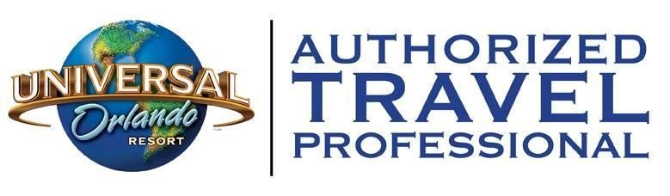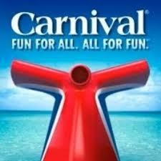
- Honeymoons  - European Vacations  - South East Asia | - Family Vacations  - Seven Wonders  - Caribbean Cruises | - Group Travel  - All-Inclusive Resorts  - US Virgin Islands
- Italy  - Japan  - China  - Thailand | - Alaska Cruises  - Greece  - Mediterranean Cruises  - Germany | - Theme Vacations  - Martinique  - St. Lucia  - African Safaris
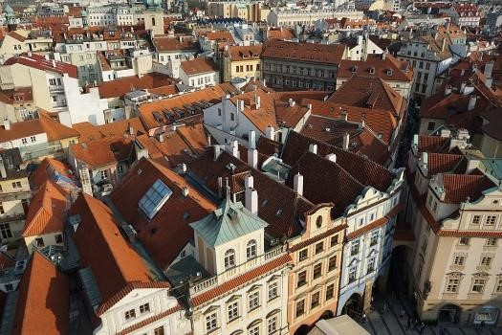

uAdventure, LLC | Trave
l

www.uadventuretravel.co
m

uAdventure Travel is the premiere travel agency for
University Study Away, Group Travel, Corporate Travel,
Destination Weddings, Honeymoons & Vacation
Planning.

Fully Insured

